FRIDAY -June 26, 2026

2:00–5:00 p.m. Registration (Pavilion)

1:00-4:00 p.m.-Early Bird Pool Party: The Ewald’s
Lifeguard will be on duty! 4343 S. State Route 202, Tipp City, OH

5:00 p.m. Cook out – (In front of Peter Cabin)
Must be pre-registered. BLUE star on badge.
Hamburgers/hot dogs, chips & water.

6:00 pm.-8:00 p.m. Family Social Event (? Location)

SATURDAY- June 27, 2026
9:00 a.m. Opening Ceremony (Mt. Studebaker)
9:00 a.m. - 2:00 p.m. Registration (Pavilion)
9:00 a.m. – 5:00 p.m. General Store (Pavilion)
9:00 a.m. – 5:00 p.m. Trace Your Lineage (Trading Post)
9:00 a.m. – 5:00 p.m. Gatherings of the Past (Trading Post)
9:00 a.m. - 12:00 p.m. SDC Cruise-In (Field/Shed)
10:00 a.m.- Car Show
Vote for your favorite model! Ballots due by 11:30 a.m.

10:00 a.m. -3:00 pm. Silent Auction (Tent #1)


10:00 a.m. – 2:00 p.m. Children’s Games/Crafts (Tent #2)

10:00 a.m. – 2:00 p.m. Food Trucks: (Near entrance gate)

10:00 a.m. – 3:00 p.m. Studebaker Cemetery (Pavilion area)
3:00 p.m.- Cemetery Tour-Sign up before 2:30 p.m.

10:00 a.m. – 4:00 p.m. Blacksmith Demo (Blacksmith Shop)

11:30 a.m. – 12:30 p.m. Guest Speaker (Peter Cabin)
Sara Kaushal- Author of the Story of Bessie Little
Book available for $20.00

12:00 p.m. Big Cheese Photo (Field by Mt. Studebaker)
Pre-order your photo. Forms are available at the General Store.

1:15 p.m. —4:00 p.m. Adult Games (18 & older) (Tent #1/Field Area)
-Sign Up Table in Pavilion

2:00 p.m. - 3:00 p.m. Genealogy Update (Peter Cabin)
Presentation given by: Bruce Whitehead

4:00 p.m. Live Auction-(Tent #1)

5:00 p.m. Johnny Wheelbarrow Race for Men & Women (18 & older)
(Field by Mt. Studebaker)
6:00 p.m. DINNER Catered dinner by:
Must be pre-registered. Hickory River
GREEN star on badge. (Food Tent)

7:00 p.m.- 9:00 p.m. Campfire/Stories/S’mores

SUNDAY – June 28, 2026

9:00 am – 10:00 a.m. Worship Service (Tent #1)
Dr. Richard Studebaker will present a short sermon.

10:00 a.m.– 12:00 p.m. Meet with Cousins and Tour the Homestead

12:00 p.m. Clean Up
PROGRAM SUBJECT TO CHANGE
ANY QUESTIONS: Board members have light green colored badges! LOST & FOUND -Pavilion.
FIRST AID and emergency medical unit will be on standby near Tent #1.

Map of Events

E
N S
W
W

Carriage House
SDC Car Display
SDC Registration Ballot Box



Shed
Blacksmith Shop
Peter Cabin
#2
#1
Pavilion
Food Tent: Table/chairs
Trading Post
Britten Cabin
Food Trucks
Gate


Thank you for joining us to celebrate 50 years of the Studebaker Family Gathering at the Homestead.

Studebaker
Family Gathering
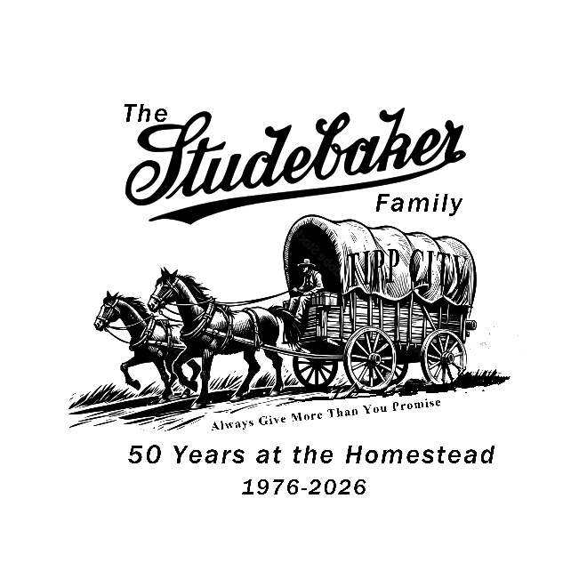
June 26-28
2026

